In a microarray screen, we found that SRE is expressed in the ventral portion of the spinal cord. My aim of this proposal is to elucidate the class and function of spinal neurons that express SRE. Using the chick and mouse, two appendage-bearing tetrapod species, I will explore the activity of SRE in limb-levels of the spinal cord. Two tools developed in the lab will greatly facilitate this characterization. I have plasmid DNA with SRE-GFP fusion protein expression as well as a SRE::Cre mouse line established.

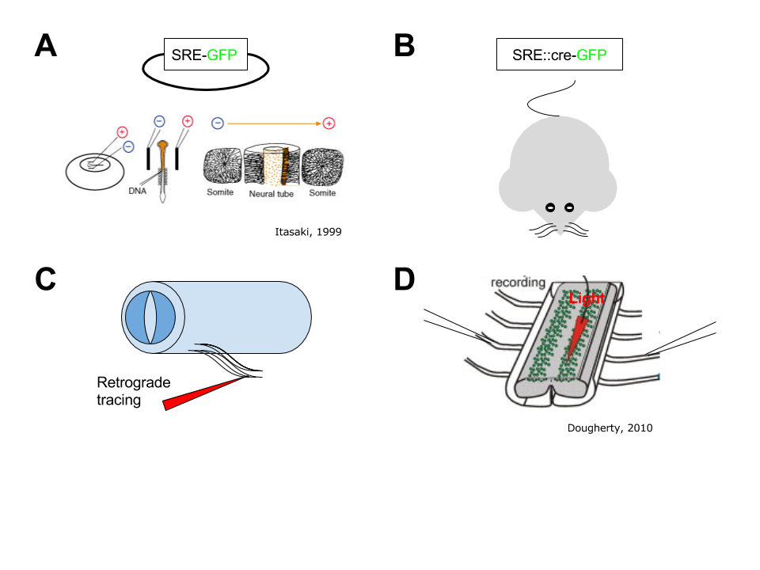

Figure - A few approaches

First, to determine if SRE activity is in progenitor neurons, I will electroporate SRE-GFP and bath chick embryonic spinal cords in BrdU at stage 14-17 (Fig 1A). I will assess co-labeled GFP with BrdU at stage 27 to allow for MN column organization and BrdU uptake. D-V and R-C position will instruct me to test for costain with other transcription factors in order to infer spinal neuron fate. For example, Hox genes for R-C position (Philippidou and Dasen 2013) and Pax genes in the early neural tube (Tanabe and Jessell 1996).

To determine SRE activity in postmitotic neurons, I will cross SRE::Cre mice to reporter ROSA26-GFP mice from JAX (SRE::Cre;YFP, Fig 1B). At postnatal day 1, after spinal neuron maturation, I will perform in situ hybridization to SRE. The co-labeled presence of GFP and in situ signal will tell me that SRE activity occurs in postmitotic neurons. On the other hand, GFP only in ventral spinal cord will tell me that SRE was expressed only in progenitor neurons.

Second, to identify the position of SRE cells in the spinal cord, I will perform in ovo chick electroporations using our SRE-GFP plasmid and compare rostral-caudal expression to LMC neurons (Fig 1A) (Dasen, Liu et al. 2003). Specifically, I will compare GFP expression to Hoxc6 and Isl1/2 expression by MNs at brachial level; to Hoxc9 and Isl1/2 expression by MNs at thoracic level; and to Hox10 and Isl1/2 expression by MNs at lumbar level. I do not anticipate that SRE will colocalize with LMC neurons (won’t rule it out either). In SRE::Cre;YFP embryonic mice, we will use Foxp1 staining, a well-known LMC transcription factor of motor neuron column identify as a proxy for Rostral-Caudal specificity (Fig 1B) (Dasen, De Camilli et al. 2008). Furthermore, to determine neurotransmitter subtype, we will perform in situ hybridization with VGlut and VGat. If both stains do not have colabeling >50%, we will attempt other neurotransmitter markers such as ChAT, dopamine, norepinephrine, and serotonin.

Third, to assess regulation by Shh, I will perform anti-Shh IgG blocking experiments as well as Shh-n activation experiments to test its effect on SRE activation (Briscoe, Sussel et al. 1999). If the pattern and timing of SRE activity is perturbed relative to its endogenous activity (defined by section 1/2), then I will proceed with asking how graded Shh signaling perturbs SRE. As Shh acts through “cross-repressive interactions” with class I and class II homeodomain transcription factors, I will assess the combinatorial expression of homeodomain transcription factors in addition to SRE expression: Class I proteins (Pax7, Dbx2, Irx3, and Pax6) and Class II proteins (Nkx6.1 and Nkx2.2) (Briscoe, Pierani et al. 2000).

Fourth, to assess synaptic partners of SRE active neurons, I will first perform retrograde tracing in ovo in the chick spinal cord (Fig 1C). I will inject rhodamine-dextran into various subsections of adjacent muscles and test for costaining with SRE (Dasen, De Camilli et al. 2008). If motorneuron subtype is not deduced from this experiment, I will presume that the SRE neurons innervate within the spinal cord. To assess synaptic partners onto SRE expressing neurons in this outcome, I will utilize the monosynaptic rabies tracing method with SRE::Cre driver line to determine starter cells (Wickersham, Lyon et al. 2007). This technique in mice will directly determine the presynaptic neurons to the starting population. For function, I will cross the SRE::Cre to a Rosa-Diptheria toxin receptor line. I will ablate SRE neurons in the spinal cord with dipteria toxin injection and monitor gait (Saito, Iwawaki et al. 2001, Crone, Zhong et al. 2009).

Fifth, to assess an evolutionary role in CPG function, I will transplant chick SRE-GFP or SRE-GFP-ablated spinal cord sections into lumbar levels. If chicks lose the ability to walk and instead “hop”, I will further test the circuit properties of SRE neurons. For example, I would predict that SRE activity is required for proper commissural interneurons (CINs) function as these neurons have been shown to project their axons across the midline of the spinal cord to control CGP (Vallstedt and Kullander 2013).

In mice, I would use the isolated spinal cord rhythmicity assay to assess “fictive” locomotor like activity from left and/or right ganglia (Fig 1D) (Dougherty and Kiehn 2010). Using Optogenetic silencing or activation of SRE neurons (Dougherty, Zagoraiou et al. 2013), I predict that either the frequency, synchronicity, or both will be perturbed.

These experiments will shed light on the function of SRE in the developing vertebrate spinal cord. Our findings may be applicable, and potentially even used as a reference point, for investigations of SRE like genes in the mammalian cortex…

**References**

Briscoe, J., A. Pierani, T. M. Jessell and J. Ericson (2000). "A homeodomain protein code specifies progenitor cell identity and neuronal fate in the ventral neural tube." Cell **101**(4): 435-445.

Briscoe, J., L. Sussel, P. Serup, D. Hartigan-O'Connor, T. M. Jessell, J. L. Rubenstein and J. Ericson (1999). "Homeobox gene Nkx2.2 and specification of neuronal identity by graded Sonic hedgehog signalling." Nature **398**(6728): 622-627.

Crone, S. A., G. Zhong, R. Harris-Warrick and K. Sharma (2009). "In mice lacking V2a interneurons, gait depends on speed of locomotion." J Neurosci **29**(21): 7098-7109.

Dasen, J. S., A. De Camilli, B. Wang, P. W. Tucker and T. M. Jessell (2008). "Hox repertoires for motor neuron diversity and connectivity gated by a single accessory factor, FoxP1." Cell **134**(2): 304-316.

Dasen, J. S., J. P. Liu and T. M. Jessell (2003). "Motor neuron columnar fate imposed by sequential phases of Hox-c activity." Nature **425**(6961): 926-933.

Dougherty, K. J. and O. Kiehn (2010). "Firing and cellular properties of V2a interneurons in the rodent spinal cord." J Neurosci **30**(1): 24-37.

Dougherty, K. J., L. Zagoraiou, D. Satoh, I. Rozani, S. Doobar, S. Arber, T. M. Jessell and O. Kiehn (2013). "Locomotor rhythm generation linked to the output of spinal shox2 excitatory interneurons." Neuron **80**(4): 920-933.

Philippidou, P. and J. S. Dasen (2013). "Hox genes: choreographers in neural development, architects of circuit organization." Neuron **80**(1): 12-34.

Saito, M., T. Iwawaki, C. Taya, H. Yonekawa, M. Noda, Y. Inui, E. Mekada, Y. Kimata, A. Tsuru and K. Kohno (2001). "Diphtheria toxin receptor-mediated conditional and targeted cell ablation in transgenic mice." Nat Biotechnol **19**(8): 746-750.

Tanabe, Y. and T. M. Jessell (1996). "Diversity and pattern in the developing spinal cord." Science **274**(5290): 1115-1123.

Vallstedt, A. and K. Kullander (2013). "Dorsally derived spinal interneurons in locomotor circuits." Ann N Y Acad Sci **1279**: 32-42.

Wickersham, I. R., D. C. Lyon, R. J. Barnard, T. Mori, S. Finke, K. K. Conzelmann, J. A. Young and E. M. Callaway (2007). "Monosynaptic restriction of transsynaptic tracing from single, genetically targeted neurons." Neuron **53**(5): 639-647.